


Scope and Storyboard for
Anti Fraud

Partner/Associate/Solicitor, BLM Office location

Table of Contents

1. Document Revision History 2
1.1. Document Location 2
1.2. Revision History 2
1.3. Approvals 2
1.4. Distribution 2
2. Summary of Scope 3
3. Screen design – Matter Fraud Summary Screen 7
4. Workflow 8
5. Navigation 8
5.1. The flow will be on an ad hoc basis 8
6. SQL Tables 8
6.1. Table 8
6.2. Lookup 8
6.3. Field 9
7. Stored Procedures 9
7.1. Fetch 9
7.2. Save 9

Document Revision History

Document Location
Full File Path
\\Man05sql\Dev\Applications\Flosuite\Scopes\HTMM\Scope and Storyboard Anti Fraud\2010-02-23 FL010 Scope and Storyboard Anti Fraud V3.doc

Revision History
Version Number | Revision Date | Summary of Changes | Changes marked | Author
V1 | 23/02/2010 | First issue |  | AEB
V2 | 18/08/2011 | Updated with input from Zurich | No | GQL
V3 | 30/08/2011 | Second issue | n/a | LMW

Reviewed by
Name | Signature | Title | Date of Issue | Version
Lisa Williams | 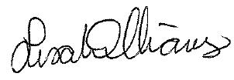 | Project Manager | 30/08/2011 | 2.0
Andrea Brown |  | Senior Test Analyst
Mark Jenkinson |  | Project Liaison Officer

Approvals
Name | Signature | Title | Date of Issue | Version

Distribution
Name | Title | Date of Issue | Version

Summary of Scope

If a matter involves Fraud then there is a set of data that must be captured under certain circumstances within the normal running of a matter. This scope describes the amendments and additions that are required within the FloCase system to allow this to happen.

Some fraud data is held in the Aderant Expert PMS so the scope encompasses the integration of the two systems to negate the need for dual entry by the user.

Screen design – Matter Fraud Summary Screen

Case Details Screen

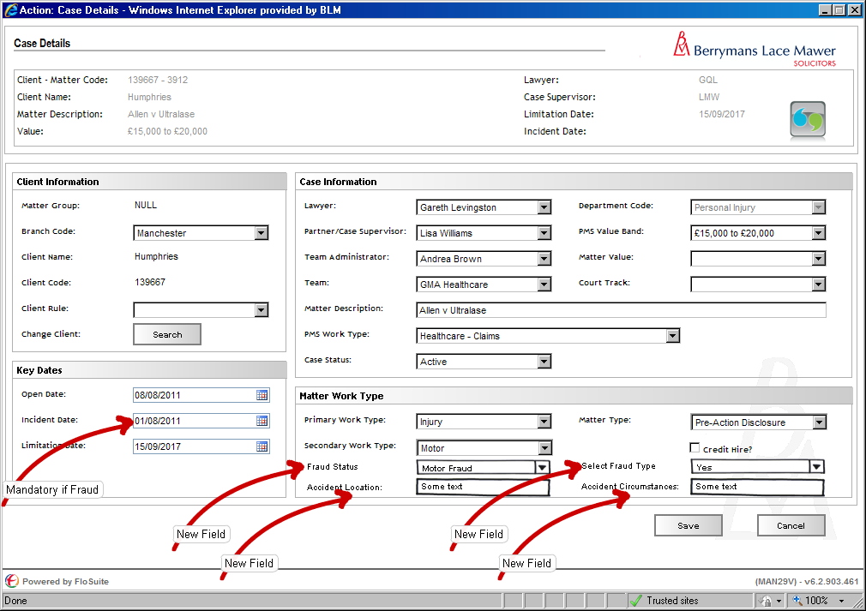
Figure 1 – Case Details Fraud Amendments

Form Availability
No change

Form Behaviour On Load

Existing stored procedure LTMM_CaseConsole_Fetch needs to be extended to include these additional fields which are all located in Adertant Expert in the tables and fields stated:
Fraud Status – _HBM_Matter_Usr_Data.fraud
Select Fraud Type – _HBM_Matter_Usr_Data.fraud_type
Accident_Location – _HBM_Matter_Usr_Data.Accident_Location
Accident_Circumstances – _HBM_Matter_Usr_Data.Accident_Details

Form Items

Fraud Status – Label as stated with associated Mandatory Combo box having the following options (Populated using LTMM_LookupCodes_Fetch with @LookupTypeCode = 'FRAUD', @BlankRow = 0) (Format Code - Description):
- MOT – Motor Fraud
- EL – EL Fraud
- PL – PL Fraud
- OTH – Other Fraud
- NA – Non Fraud
Select Fraud Type – Label as stated with associated Combo box having the following options (Populated using LTMM_LookupCodes_Fetch with @LookupTypeCode = 'FRAUDTYPE', @BlankRow = 1) (Format Code - Description):
- CON – Contrived/False
- EXI – Exaggerated Injury
- EXN – Exaggerated Non PI
- FAL – False Witness
- FIR – Fire
- LM10 – Linked Market Files 10 plus
- LM5 – Linked Market Files 5-9
- LSI – Low Speed Impact
- LSO – LSI & Other
- OTH – Other
- PHA – Phantom Passenger
- PHM – PH Misrepresentation
- PRE – Pre-cover Loss (ph fraud)
- STA – Staged Accident / Deliberate
- THE – Theft
- FDOC – False Documents
Only visible if Fraud Status <> ‘’ Mandatory if visible.
Accident Location - Label as stated with associated textbox Only visible if Fraud Status <> ‘NA’ Mandatory if visible.
Accident Circumstances - Label as stated with associated textbox Only visible if Fraud Status <> ‘NA’ Mandatory if visible.
Incident Date – Existing control but now Mandatory if Fraud Status <> ‘NA’.

Form Behaviour on Submit

Existing stored procedure LTMM_Case_Save needs to be extended to include these additional fields which are all located in Adertant Expert in the tables and fields stated:
Fraud Status – _HBM_Matter_Usr_Data.fraud
Select Fraud Type – _HBM_Matter_Usr_Data.fraud_type
Accident_Location – _HBM_Matter_Usr_Data.Accident_Location
Accident_Circumstances – _HBM_Matter_Usr_Data.Accident_Details

Note: When updating data in the Aderant Expert database you must ensure that you update the LAST_MODIFIED = GetaDate() in the affected table as part of the process

Contacts Screen – Add/Amend Claimant/Defendant Details

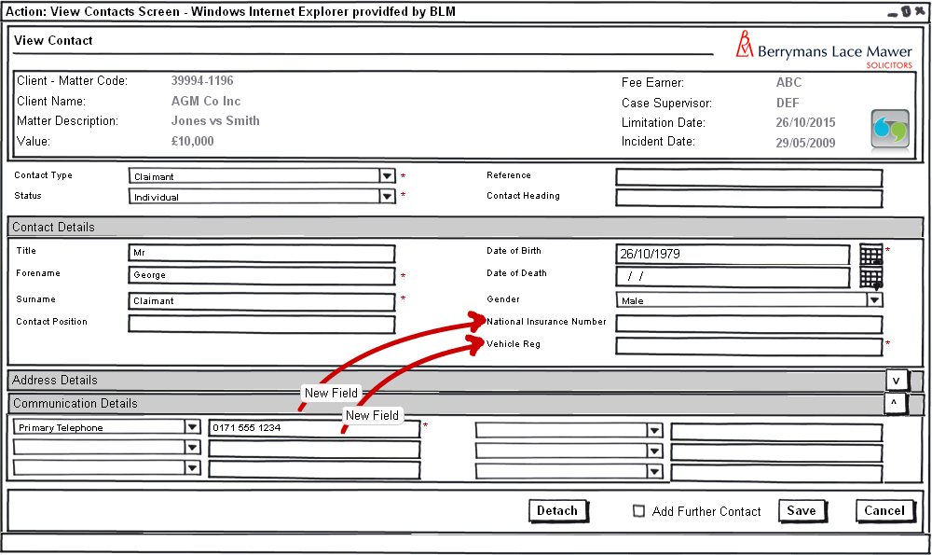
Figure 2 – View Contacts Screen – Claimant

Form Availability
No Change

Form Behaviour On Load

LTMM_CaseContacts_Fetch stored procedure that is executed upon form load needs to be extended to include the following new columns in the fetch, with the values being displayed in the corresponding fields on the form:
- National Insurance Number
- Vehicle Registration

A new fetch LTMM_AssessFraud_Fetch should be executed upon load to return the following information to allow fraud status to be assessed upon form load:
Fraud Status – same database field as Fraud Status From case details (see section 3.1) which will return the following:
- MOT – Motor Fraud
- EL – EL Fraud
- PL – PL Fraud
- OTH – Other Fraud
- NA – Non Fraud

Form Items

National Insurance Number– Label as stated with associated textbox Mandatory if Fraud Status <> ‘NA’
(Only visible if contact type is Claimant or Defendant).
Vehicle Registration – Label as stated with associated textbox Only visible if Fraud Status = ‘MOT’ Mandatory if visible (Only visible if contact type is Claimant or Defendant).
Date of Birth – Existing control now Mandatory if Fraud Status <> ‘NA’ and Contact type is Claimant or Defendant.
Primary Telephone Number – If Fraud Status <> ‘NA’ it is now compulsory to add the Claimants primary telephone number and Contact type is Claimant or Defendant.
Add Further Contact – Label as stated with associated check box. This facility should be available for all contacts.

Form Behaviour on Save

If Add Further Contact = Checked return to Search Contacts

If Add Further Contact = Unchecked return to the Matter Landing Page.

LTMM_MatterContact_Save stored procedure that is executed upon form load needs to be extended to include the following new columns in the save, with the values mapped to the corresponding fields on the form:
- National Insurance Number
- Vehicle Registration

Form Behaviour on Cancel

No Change

Matter Fraud Summary Tab

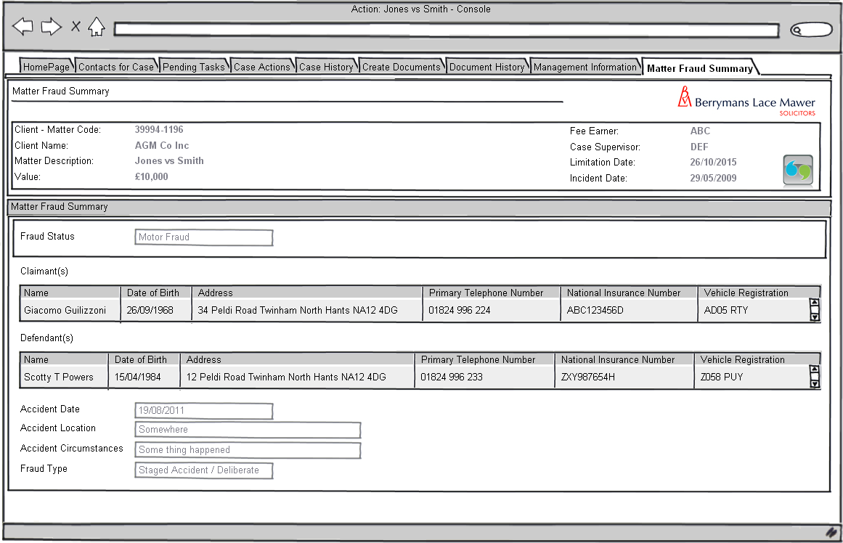
Figure 3 – Matter Fraud Summary Tab

Read only Matter Fraud summary tab with the following definition

Form Availability

Available as a tab on the matter landing page if Fraud Status, Entered on Case details screen (see section 3.1), <> ‘NA’

Form Behaviour On Load

Use existing LTMM_CaseConsole_Fetch stored procedure (as extended in section 3.1) to pre-populate the following information on this screen:
- Fraud Classification
- Accident Date
- Accident Location
- Accident Circumstances
- Fraud Type

Claimant(s) and Defendant(s) grids should be pre-populated using the existing LTMM_CaseContacts_Fetch and specifying the role codes as Claimant and Defendant accordingly.

Form Items

Fraud Status – Label as stated with associated read only textbox
Claimant(s) – Label as stated with associated Grid populated by LTMM_CaseContacts_Fetch using the role code Claimant
Defendant(s) – Label as stated with associated Grid populated by LTMM_CaseContacts_Fetch using the role code Defendant
Accident Date – Label as stated with associated read only textbox
Accident Location – Label as stated with associated read only textbox
Accident Circumstances – Label as stated with associated read only textbox
Fraud Type – Label as stated with associated read only textbox

Form Behaviour on Save

n/a

Form Behaviour on Cancel

n/a

Contacts Screen – Add/Amend Witness Details

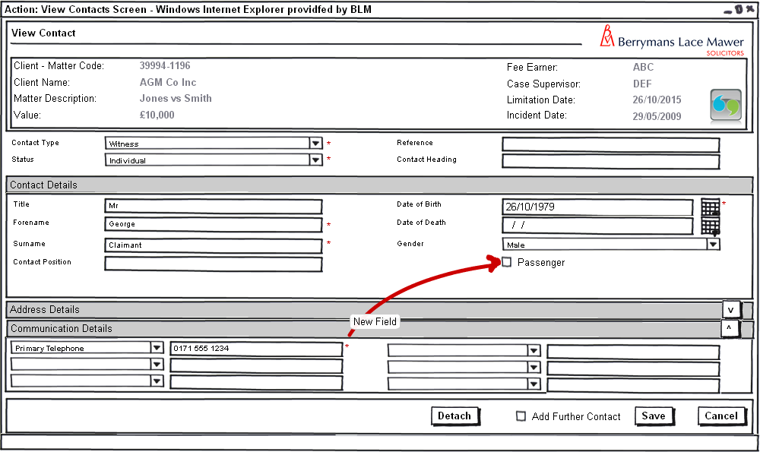
Figure 2 – View Contacts Screen – Witness

Form Availability
No Change

Form Behaviour On Load

LTMM_CaseContacts_Fetch stored procedure that is executed upon form load needs to be extended to include the following new columns in the fetch, with the values being displayed in the corresponding fields on the form:
- Passenger

A new fetch LTMM_AssessFraud_Fetch should be executed upon load to return the following information to allow fraud status to be assessed upon form load:
Fraud Status – same database field as Fraud Status From case details (see section 3.1) which will return the following:
- MOT – Motor Fraud
- EL – EL Fraud
- PL – PL Fraud
- OTH – Other Fraud
- NA – Non Fraud

Form Items

Passenger – Label as stated with associated check box Only visible if Fraud Status = ‘MOT’ Mandatory if visible (Only visible if contact type is Witness).

Form Behaviour on Save

LTMM_MatterContact_Save stored procedure that is executed upon form load needs to be extended to include the following new columns in the save, with the values mapped to the corresponding fields on the form:
- Passenger

Form Behaviour on Cancel

No Change

Workflow

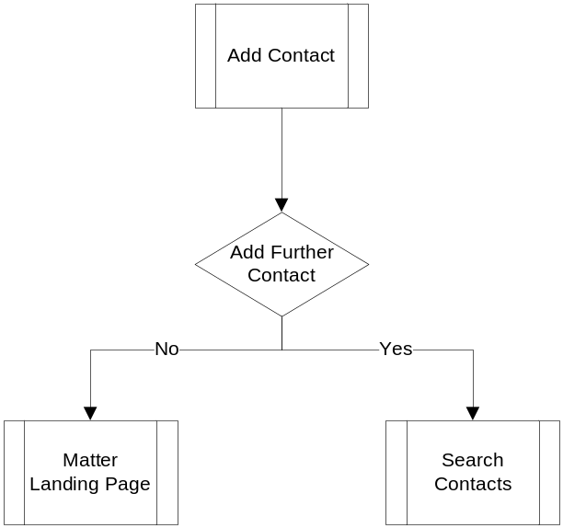
Figure 4 – New Add Contact Work Flow

Navigation

Where will the Flow be launched from

No changes to existing setup

Where should the Flow return to

No changes to existing setup, other than the alteration to the contacts work flow as detailed in section 4

SQL Tables

Table

n/a

Lookup

The following new lookups are required:

Fraud Status (LookupTypeCode = 'FRAUD') with the following options:
- MOT – Motor Fraud
- EL – EL Fraud
- PL – PL Fraud
- OTH – Other Fraud
- NA – Non Fraud

Select Fraud Type (LookupTypeCode = 'FRAUDTYPE'), with the following options:
- CON – Contrived/False
- EXI – Exaggerated Injury
- EXN – Exaggerated Non PI
- FAL – False Witness
- FIR – Fire
- LM10 – Linked Market Files 10 plus
- LM5 – Linked Market Files 5-9
- LSI – Low Speed Impact
- LSO – LSI & Other
- OTH – Other
- PHA – Phantom Passenger
- PHM – PH Misrepresentation
- PRE – Pre-cover Loss (ph fraud)
- STA – Staged Accident / Deliberate
- THE – Theft
- FDOC – False Documents

New contact types (See associated Ticket)
- Hire company
- Recovery/storage company
- Accident management company
- Engineer

Field

The Following new Fields are required in the MatterContacts table:
- MatterContacts_NINumber – Type nVarchar(255) allow nulls
- MatterContacts_VehicleReg – Type nVarchar(255) allow nulls
- MatterContacts_Passenger – Type bit default to 0

Stored Procedures

Fetch

Existing stored procedure LTMM_CaseConsole_Fetch needs to be extended to include these addition fields which are all located in Adertant Expert in the tables and fields stated:
Fraud_Status – _HBM_Matter_Usr_Data.fraud
Fraud_Type – _HBM_Matter_Usr_Data.fraud_type
Accident_Location – _HBM_Matter_Usr_Data.Accident_Location
Accident_Circumstances – _HBM_Matter_Usr_Data.Accident_Details

Existing stored procedure LTMM_CaseContacts_Fetch needs to be extended to include the following new columns from the MatterContacts table (as detailed in section 6.3 above) in the fetch:
- MatterContacts_NINumber
- MatterContacts_VehicleReg
- MatterContacts_Passenger

A new fetch LTMM_AssessFraud_Fetch is required which will return the fraud type associated with the matter from Aderant Expert, the SQL it will need to execute is as follows (using the data held in the system settings table to connect to the correct Aderant environment):

SELECT mud.fraud AS Fraud_StatusCode, f.fraud_description as Fraud_StatusDesc
FROM _HBM_Matter_Usr_Data m
INNER JOIN _HBL_Fraud f on m.fraud = f.fraud_code
INNER JOIN ApplicationInstance ai ON m.matter_uno = ai.AExpert_MatterUno
WHERE ai.CASEID = <<Passed Caseid>>

Save

Existing stored procedure LTMM_Case_Save needs to be extended to include these addition fields which are all located in Adertant Expert in the tables and fields stated:
@pFraud_Status Varchar(4) – _HBM_Matter_Usr_Data.fraud
@pFraud_Type Varchar(4) – _HBM_Matter_Usr_Data.fraud_type
@pAccident_Location Varchar(80) – _HBM_Matter_Usr_Data.Accident_Location
@pAccident_Circumstances Varchar(100) – _HBM_Matter_Usr_Data.Accident_Details

Note: When updating data in the Aderant Expert database you must ensure that you update the LAST_MODIFIED = GetaDate() in the affected table as part of the process

LTMM_MatterContact_Save stored procedure that is executed upon form load needs to be extended to include the following new columns in the save, with the values mapped to the corresponding columns in the MatterContacts table (as detailed in section 6.3 above):
- @pMatterContacts_NINumber – Type nVarchar(255) allow nulls
- @pMatterContacts_VehicleReg – Type nVarchar(255) allow nulls
- @pMatterContacts_Passenger – Type bit default to 0

Document Templates

n/a

/tmp/lo/0000.doc

